AI ASSISTED CODING – LAB ASSIGNMENT 3.2

Name: Sk. Khaja Nawaz
Course: B.Tech – CSE
Subject: AI Assisted Coding
HTNO: 2303A51971
Year / Semester: III / II
Regulation: R23

Task 1: Progressive Prompting – Calculator Design Aim
To understand how improving the prompt step by step affects the quality and correctness of AI-generated code.
Step-1: Initial Prompt Prompt Create a calculator function.
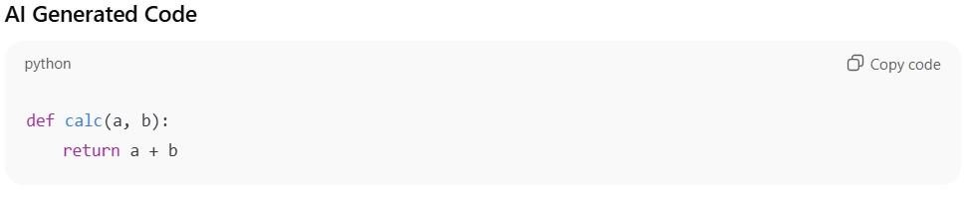

Step-2: Refined Prompt Prompt
Create a calculator program in Python that performs addition, subtraction, multiplication and division.
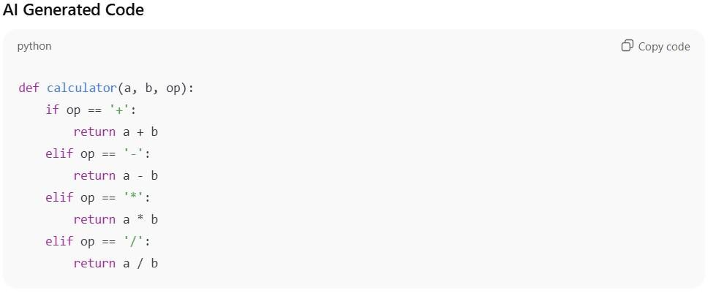

Step-3: Final Prompt (Context Managed Prompt) Prompt
Write a complete Python calculator program with user input, menu-driven operation selection, and proper error handling.
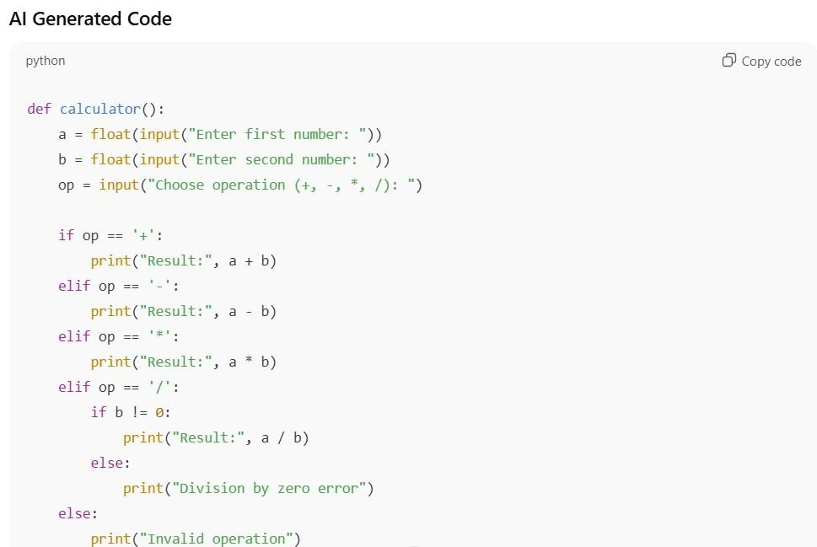

Comparison

Feature | Initial Prompt | Refined Prompt | Final Prompt
Operations | Only addition | All four | All four
User input | No | No | Yes
Error handling | No | No | Yes
Program quality | Poor | Medium | Very Good

Observation
When the prompt was small, the code was also very simple.
As the prompt became clearer and more detailed, the generated code became better and more complete.
The final prompt gave a proper working calculator program.

Conclusion
This task shows that writing good and clear prompts is very important when using AI for coding.
Better prompts produce better programs with fewer mistakes.

Task 2: Refining Prompts for Sorting Student Marks Aim
To study how improving the clarity of a prompt helps in generating better and more accurate sorting logic.

Step-1: Initial (Vague) Prompt Prompt Sort the student marks.
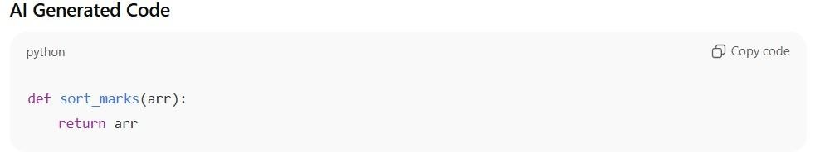

Step-2: Refined Prompt Prompt
Write a Python program to sort student marks in ascending order without using built-in functions.
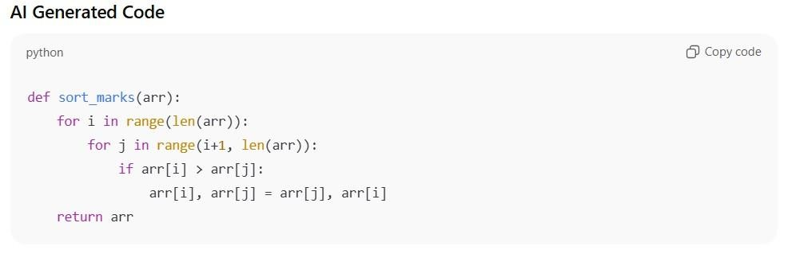

Observation
The vague prompt produced almost no useful code.
After improving the prompt with clear instructions, the AI generated a correct and efficient sorting program.

Conclusion
This task shows that when we explain clearly what we want, the AI gives much better results.
Clear prompts help avoid mistakes and improve code quality.

Task 3: Few-Shot Prompting for Prime Number Validation Aim
To observe how giving examples in the prompt improves the correctness of the AIgenerated prime number program.

Step-1: Few-Shot Prompt Prompt with Examples
2 → Prime
4 → Not Prime 17 → Prime
1 → Not Prime
Write a Python function to check whether a number is prime.
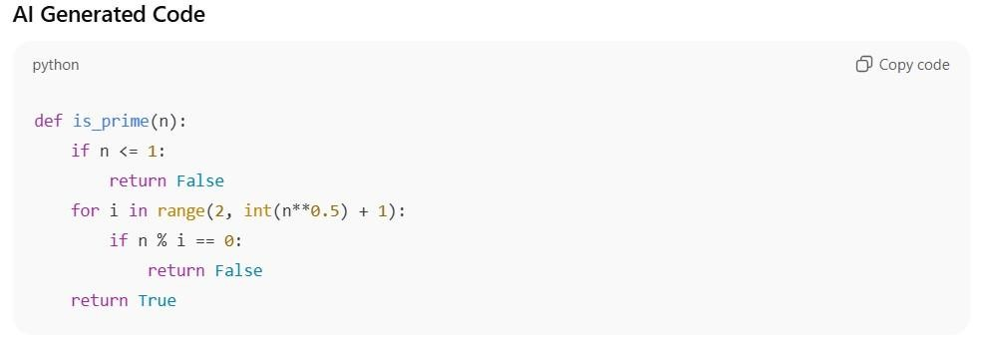

Observation
Because examples were given, the AI understood the problem clearly.
It handled edge cases like 1 and used an efficient method for checking prime numbers.

Conclusion
Few-shot prompting helps the AI generate more correct and reliable code. Providing examples makes the AI understand the requirement better.

Task 4: Prompt-Guided UI Design for Student Grading System Aim
To create a simple user interface program for calculating total marks, percentage, and grade using clear prompts.

Prompt Used
Create a Python program that takes student details and marks, calculates total, percentage, and assigns grade, and displays the result clearly.
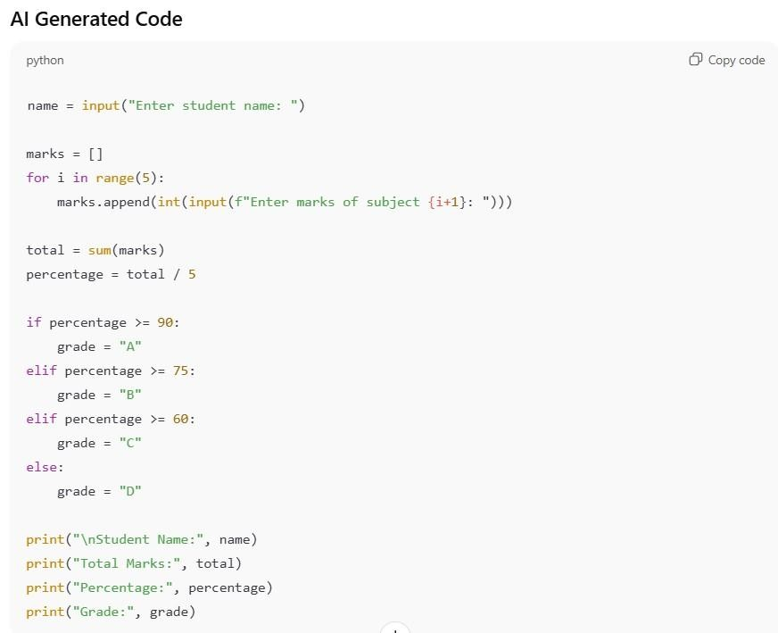

Sample Output
Student Name: Pavan
Total Marks: 420 Percentage: 84 Grade:
B

Observation
Because the prompt was clear, the AI generated a complete program with correct calculations and easy-to-read output.

Conclusion
Clear prompts help in building well-structured programs with fewer errors. The program became simple and useful for real-world use.
Task 5: Analyzing Prompt Specificity in Unit Conversion Functions

Aim
To study how giving clear and specific instructions in a prompt improves the accuracy of AIgenerated unit conversion programs.

Prompt Used
Write a Python program to convert kilometers to miles and miles to kilometers using correct formulas and proper function structure.
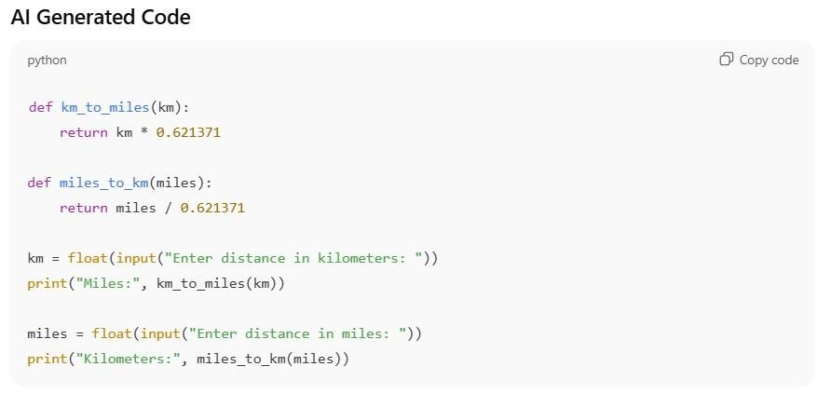

Sample Output
Enter distance in kilometers: 10 Miles:
6.21371
Enter distance in miles: 5
Kilometers: 8.04672

Observation
Because the prompt was very clear about the task and formulas, the AI produced accurate and well-organized code.

Conclusion
When the prompt is specific and detailed, the generated code becomes more correct and easier to use.

